Rev. 7-20

Email: __________________________________

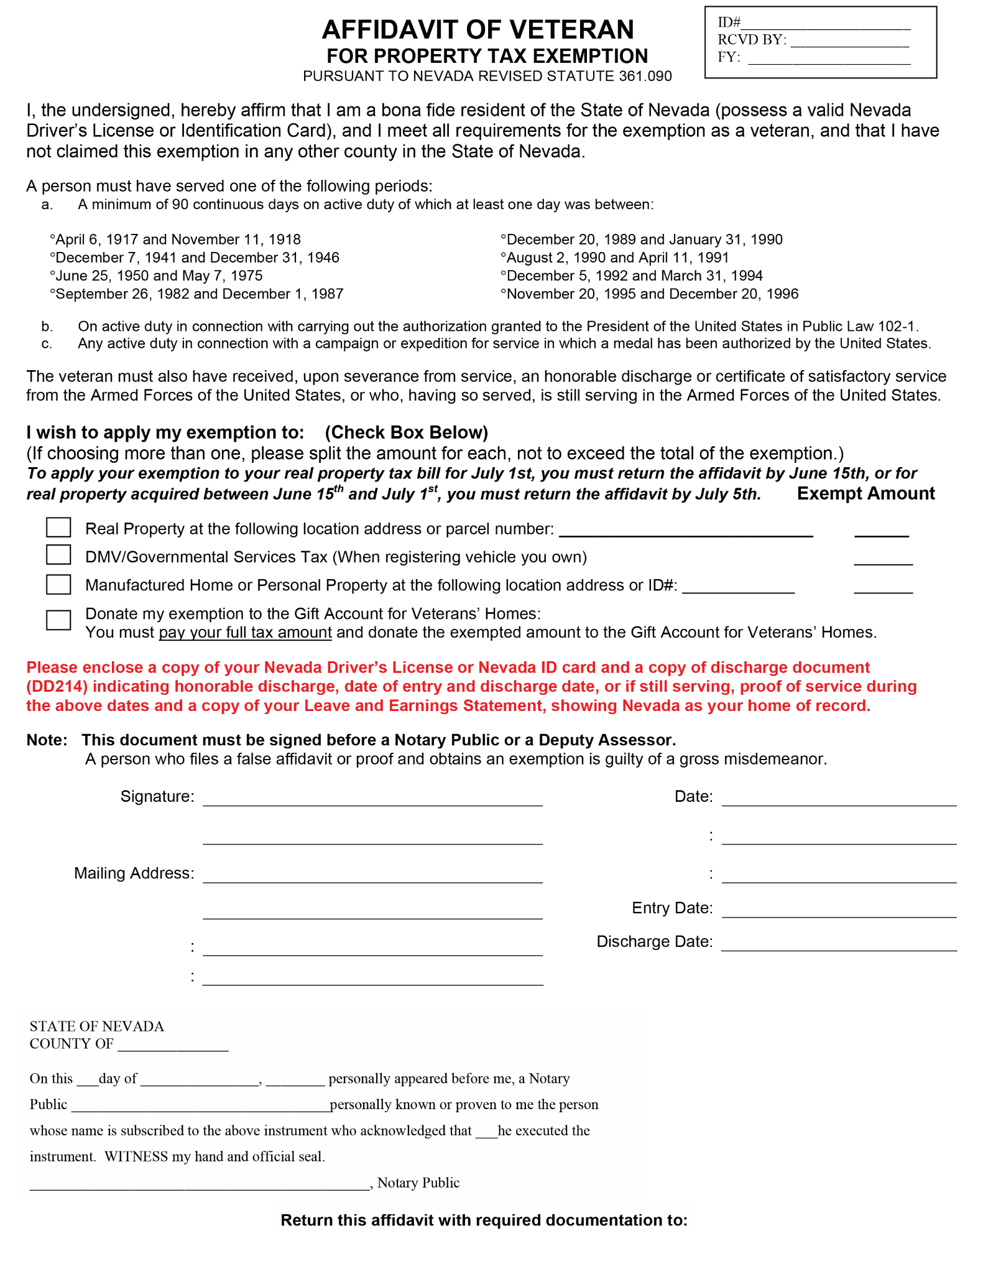

Or email to: AOCustomerServiceRequests@ClarkCountyNV.gov